Mustard Potato Salad Recipe

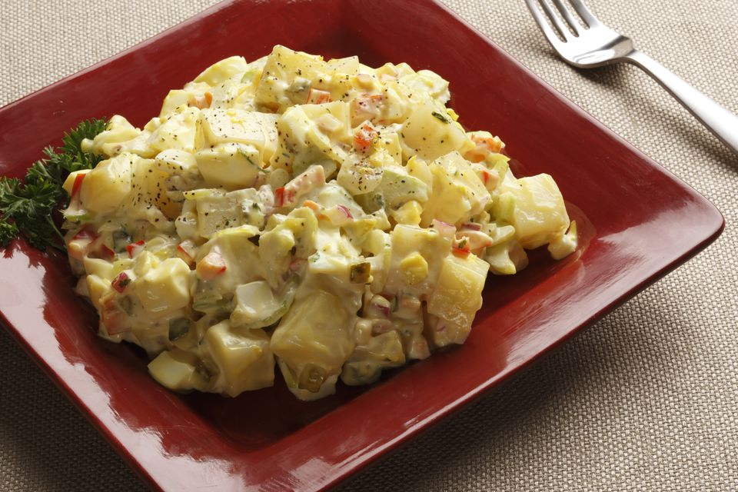

Tim Hawley / Getty Images

* 30 hrs 30 mins
* Prep: 30 mins,

* Cook: 30 hrs
* Yield: 8 to 10 servings

(6)

BY [PEGGY TROWBRIDGE FILIPPONE](https://www.thespruce.com/peggy-trowbridge-filippone-1802305)

Updated 11/09/16

* Share
* Pin
* Email

[PRINT](javascript:window.print())

Don't buy that mushy from the grocery store deli. It's easy to make your own. Waxy potatoes (such as Rose Red or Yukon Gold) make the best potato salad because the cooked potatoes hold together better than Idahos or russets. Leave the skins on not only to save time, but also for added color, flavor, and nutrients. Mustard potato salad is the perfect side dish for picnics, potlucks, barbecues, or just a simple family dinner.

What You'll Need

* 6 medium red [potatoes](https://www.thespruce.com/soups-stews-chili-4128562), boiled in skins until tender, and cooled
* 1/2 large
* [sweet onion](https://www.thespruce.com/sweet-onion-selection-and-storage-1807816), diced
* 2 large stalks of celery, diced
* 5
* [hard-boiled eggs](https://www.thespruce.com/how-to-make-hard-boiled-eggs-1802345), chopped (reserve 1 to cut into wedges for garnish)
* 1 teaspoons celery seed
* 1/4 cup sweet pickle relish
* 1 teaspoon kosher
* [salt](https://www.thespruce.com/salt-varieties-and-types-1809320), or to taste
* 1/2 teaspoon freshly ground black
* [pepper](https://www.thespruce.com/peppercorn-and-pepper-varieties-1809318)
* 1/2 cup
* [mayonnaise](https://www.thespruce.com/mayonnaise-tips-and-hints-1808082)
* 1/4 cup prepared yellow
* [mustard](https://www.thespruce.com/mustard-varieties-1808087)
* 1 Tablespoons white or pickle juice
* 8 cherry
* [tomatoes](https://www.thespruce.com/tomato-cooking-tips-and-hints-1808068) for garnish
* Parsley for garnish
* Sweet Hungarian
* [paprika](https://www.thespruce.com/paprika-storage-and-cooking-tips-1809316) for garnish, optional

How to Make It

Cut cooked potatoes into cubes with skin on (or scrape off the skin with a butter knife) and cut into cubes. Place in a large mixing bowl with sweet onion, celery, chopped hard-boiled eggs, celery seed, pickle relish, salt, and pepper. Toss gently.  
  
Whisk together mayonnaise, mustard, and vinegar or pickle juice. Mix into potatoes and until combined. Try not to break up the potatoes while mixing.  
  
Decorate with hard-boiled egg wedges, tomatoes, and parsley.

Sprinkle with a light dusting of sweet paprika. Refrigerate mustard potato salad at least 4 hours to let flavors meld before serving.

Rate This Recipe